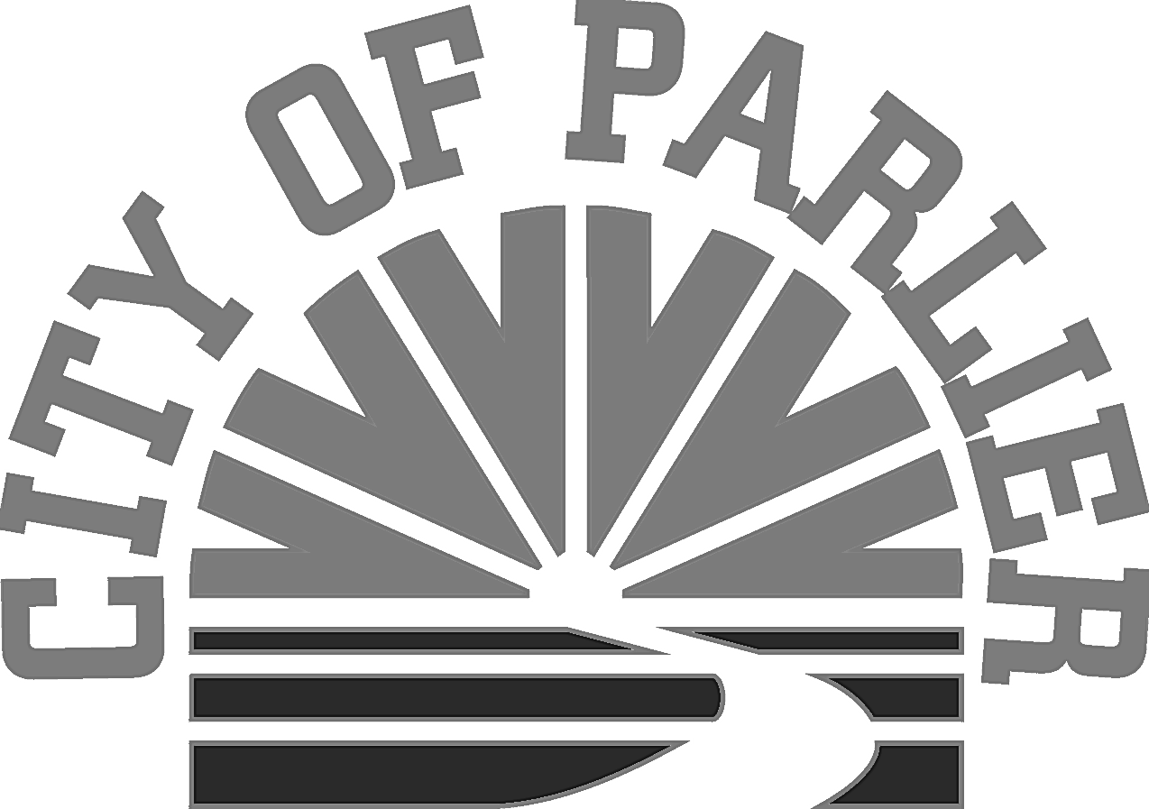

MINUTES

a joint meeting of the CITY COUNCIL of the
City of parlier and the successor agency of the parlier redevelopment agency

SPECIAL meetinG
Wednesday November 8, 2017

- CALL TO ORDER/WELCOME:

A Joint Meeting of the City Council of the City of Parlier and the Successor Agency of the Parlier Redevelopment Agency was held at the City Council Chambers located at 1100 E. Parlier Avenue, Parlier, California 93648. Mayor Pro Tem Jose Escoto called the meeting to order at 6:35 P.M.
ROLL CALL: Mayor Pro-Tem Jose Escoto, Councilwoman Diane Maldonado, Councilman Noe Rodriguez, Councilman Trinidad Pimentel, City Clerk Dorothy Garza.
Absent: Mayor Alma Beltran.
Staff Present: Police Chief Jose Garza, City Attorneys Mary Lerner and Lee Burdick, City Manager Sam Escobar, City Planner Jeff O’Neal, City Engineer Philip Romero, Executive Assistant/Deputy City Clerk Bertha Augustine.

Flag Salute: Mayor Pro Tem Jose Escoto.

- ADDITIONS/DELETIONS TO THE AGENDA: None.

- ADMINISTRATIVE REPORTS:

ENGINEERING DEPARTMENT:

3-A. SUBJECT: SB 1 Project List Designation – The new Gas Tax Legislation, SB 1, which provides additional funding to the City, requires an initial designation for a project to use those funds and annual reporting thereafter.

  - Staff Report – Philip Romero
  - Public Comments – None.
  - City Council Comments/Review/Action – Approved City Engineer’s recommended project designation.

The City Council approved the SB 1 Project Designation List and adopted Resolution 2017-84, “Designating a Project for the Road Repair and Accountability Act of 2017 and including the Project in the FY 2017-2018 Budget.”

M/S/C: Motion to approve Resolution 2017-84 by Maldonado, 2nd by Rodriguez. 4 – 0. Carried. Absent: Mayor Beltran.

ADMINISTRATION DEPARTMENT:

3-B. SUBJECT: First Reading – Ordinance 2017-03 Relating to Marijuana and Cannabis by: (1) Adding Commercial Cannabis Operations and Indoor Cultivation to the Definition of Permitted Uses in the M-1 Zone District, Sections 18.28.010 and 18.28.020, Subject to Specified Limitations; (2) Repealing the City’s Existing Regulations Relating to Marijuana Set Forth in Sections 18.04.347 and 18.32.420; and (3) Adding Chapter 18.55 (Section 18.55.010, et seq.) Setting Forth the Regulatory Framework for Commercial Cannabis Operations and Personal Use Cultivation (Medical and Recreational/Adult Use)

- Staff Report – Sam Escobar/Deputy City Attorney Lee Burdick.
- Public Comments – Lucy Pimentel supports Ordinance.
- City Council Comments/Review/Action: Approved amendments to draft ordinance for second reading.

The City Council introduced Ordinance 2017-03, conducted the first reading, received public testimony on it, and considered any proposed changes.

M/S/C: Motion to amend the proposed ordinance to: (1) include daycare centers and youth centers within the 1000-foot buffer zones proposed to protect schools; and (2) create a structured “Revenue Raising Fee” that includes a tiered, square-footage-based component and a three percent (3%) of gross receipts fee component by Pimentel, 2nd by Escoto. 4-0.carried.
Roll Call Vote: Pimentel yes, Rodriguez yes, Escoto yes and Maldonado yes.
Absent: Mayor Beltran.

- BRIEF COMMENTS: COUNCILCOMMUNICATIONS/COMMENTS:

CITY MANAGER: None.

CITY ATTORNEY: None.

CITY COUNCIL: None.

- PUBLIC COMMENTS ON CLOSED SESSION: None.

- CLOSED SESSION: (8:20 P.M. – 9:07 P.M.)

6-A. Government Code Section 54956.9(d)(1) CONFERENCE WITH LEGAL COUNSEL-EXISTING LITIGATION: City of Parlier v. The Dow Chemical Co., et al., San Bernardino Superior Court, Judicial Council Coordination Proceeding No. 4435 Case No. CGC-12-523400

6-B. Government Code Section 54956.8 CONFERENCE WITH REAL PROPERTY
NEGOTIATORS:
Property: Parcels 4 and 9 located in the City’s industrial park at the cross-streets of Milton Avenue and Industrial Drive.
Agency Negotiator(s): Jim Simon and Nate Gunderman, RSG.
Negotiating Parties: Genezen, L.L.C.
Under Negotiation: Price, terms and conditions.

ACTION ON CLOSED SESSION

Nothing to report.

- ADJOURNMENT:

Mayor Pro Tem Escoto adjourned the meeting at 9:07 P.M.

____________________________________________
Dorothy Garza, City Clerk

City Resolution adopted: 2017-84
City Ordinance first reading: 2017-03

ADA Notice: In compliance with the American with Disabilities Act, if you need special assistance to participate in this meeting, please contact the City Clerk at (559) 646-3545 ext. 227. Notification 48 hours prior to the meeting will enable the City to make arrangements to ensure accessibility to this meeting.

Documents: Any writings or documents provided to a majority of the City Council regarding any item on this agenda will be made available for public inspection at the front counter at City Hall located at 1100 E. Parlier Avenue, Parlier, CA during normal business hours. In addition, most documents are posted on the City’s website at parlier.ca.us

STATEMENT ON RULES OF DECORUM AND ENFORCEMENT

The Brown Act provides that members of the public have a right to attend public meetings, to provide public comment on action items and under the public forum section of the agenda, and to criticize the policies, procedures, or services of the city or of the acts or omissions of the city council. The Brown Act also provides that eh City Council has the right to exclude all persons who willfully cause a disruption of a meeting so that it cannot be conducted in an orderly fashion.
During a meeting of the Parlier City Council, there is a need for civility and expedition in the carrying out of public business in order to ensure that the public has a full opportunity to be heard and that the Council has an opportunity to conduct business in an orderly manner. The following is provided to place everyone on notice of the rules of decorum and enforcement.

GENERAL RULES OF DECORUM
While any meeting of the City Council is in session, the following rules of decorum shall be observed:

1. All remarks shall be addressed to the City Council as a whole and not to any single member, unless in response to a question from a member of the City Council.
2. A person who addresses the City Council under public comment for a specific agenda item or under the Public Forum section of the agenda may not engage in speech or conduct (I) which is likely to provoke others to violent or riotous behavior, (ii) which disturbs the peace of the meeting by loud and unreasonable noise, (iii) which is irrelevant or repetitive, or (iv) which disrupts, disturbs, or otherwise impedes the orderly conduct of any City Council meeting.
3. A person, other than members of the Council and the person, who has the floor, shall not be permitted to enter into the discussion unless requested by the Mayor to speak.
4. Members of the City Council may not interrupt a person who has the floor and is making public comments. Members of the City Council shall wait until a person completes his or her public comments before asking questions or commenting. The Mayor shall then ask Council members if they have comments or questions.
5. No person in the audience at a Council meeting shall engage in disorderly or boisterous conduct, including the utterance of loud, threatening or abusive language, whistling, stamping of feet or other acts which disturb, disrupt or otherwise impeded the orderly conduct of any Council meeting.

