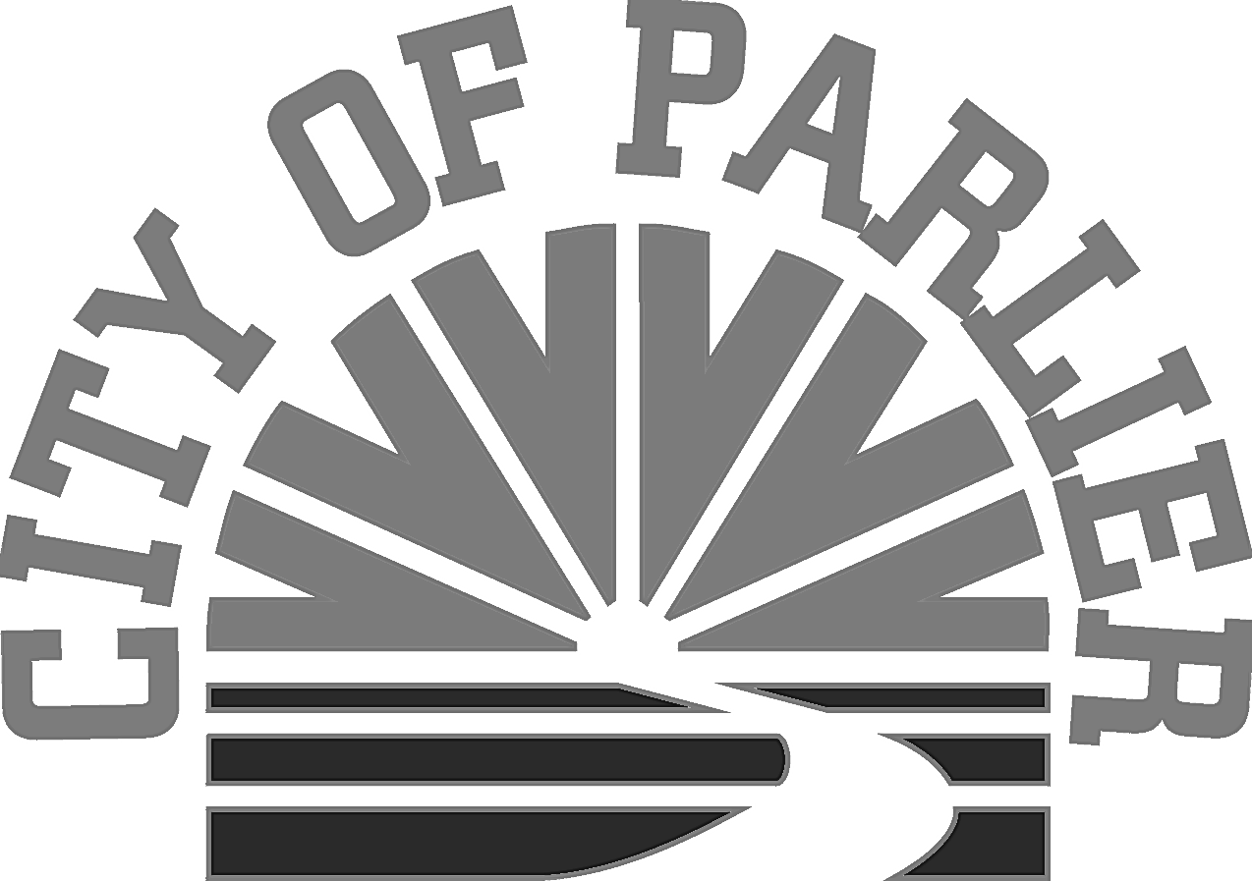

a meeting of the CITY COUNCIL of the
City of parlier

“SPECIAL meeting”
RAFT

DATE: Thursday, August 24, 2017
TIME: 6:30 P.M.
PLACE: Parlier City Council Chambers
1100 E. Parlier Avenue
Parlier, CA 93648

- CALL TO ORDER/WELCOME:
Roll Call: Mayor Alma M. Beltran, Mayor Pro-Tem Jose Escoto, Councilwoman Diane Maldonado, Councilman Noe Rodriguez, Councilman Trinidad Pimental, City Clerk Dorothy Garza.

Flag Salute: Mayor Alma M. Beltran

- PUBLIC COMMENTS ON CLOSED SESSION:
(THIS PORTION OF THE MEETING IS RESERVED FOR PERSONS DESIRING TO ADDRESS THE COUNCIL ON AN ITEM WHICH IS TO BE CONSIDERED DURING CLOSED SESSION. SPEAKERS SHOULD LIMIT THEIR COMMENTS TO FIVE (5) MINUTES.)

- CLOSED SESSION:
3-A . Government Code Section 54956.8
CONFERENCE WITH REAL PROPERTY NEGOTIATORS
Property: 741 Tulare, 741.5 Tulare and 580 Tulare
Agency Negotiator: Samuel Escobar, City Manager
Negotiating Parties: Harpreet Bali, Starrrhub
Under Negotiation: Price and terms of potential lease of property

- ADMINISTRATIVE REPORTS:

ADMINISTRATION DEPARTMENT:
4-A. SUBJECT: Council to approve the lease agreements for the rental of 741 Tulare, 741 ½ Tulare, and 580 Tulare Street to be used by Starrrhub as offices.

  - Staff Report
  - Public Comments
  - City Council Comments/Review/Action

RECOMMENDATION: City Council authorize the City Manager to sign a lease for the rental of 741 Tulare, 741 ½ Tulare, and 580 Tulare Street to be used by Starrrhub as offices. Upon review and approval of agreements by City Attorney.

- ADJOURNMENT:

ADA Notice: In compliance with the American with Disabilities Act, if you need special assistance to participate in this meeting, please contact the City Clerk at (559) 646-3545 ext. 227. Notification 48 hours prior to the meeting will enable the City to make arrangements to ensure accessibility to this meeting.

Documents: Any writings or documents provided to a majority of the City Council regarding any item on this agenda will be made available for public inspection at the front counter at City Hall located at 1100 E. Parlier Avenue, Parlier, CA during normal business hours. In addition, most documents are posted on the City’s website at parlier.ca.us

STATEMENT ON RULES OF DECORUM AND ENFORCEMENT

The Brown Act provides that members of the public have a right to attend public meetings, to provide public comment on action items and under the public forum section of the agenda, and to criticize the policies, procedures, or services of the city or of the acts or omissions of the city council. The Brown Act also provides that eh City Council has the right to exclude all persons who willfully cause a disruption of a meeting so that it cannot be conducted in an orderly fashion.
During a meeting of the Parlier City Council, there is a need for civility and expedition in the carrying out of public business in order to ensure that the public has a full opportunity to be heard and that the Council has an opportunity to conduct business in an orderly manner. The following is provided to place everyone on notice of the rules of decorum and enforcement.

GENERAL RULES OF DECORUM
While any meeting of the City Council is in session, the following rules of decorum shall be observed:

1. All remarks shall be addressed to the City Council as a whole and not to any single member, unless in response to a question from a member of the City Council.
2. A person who addresses the City Council under public comment for a specific agenda item or under the Public Forum section of the agenda may not engage in speech or conduct (I) which is likely to provoke others to violent or riotous behavior, (ii) which disturbs the peace of the meeting by loud and unreasonable noise, (iii) which is irrelevant or repetitive, or (iv) which disrupts, disturbs, or otherwise impedes the orderly conduct of any City Council meeting.
3. A person, other than members of the Council and the person, who has the floor, shall not be permitted to enter into the discussion unless requested by the Mayor to speak.
4. Members of the City Council may not interrupt a person who has the floor and is making public comments. Members of the City Council shall wait until a person completes his or her public comments before asking questions or commenting. The Mayor shall then ask Council members if they have comments or questions.
5. No person in the audience at a Council meeting shall engage in disorderly or boisterous conduct, including the utterance of loud, threatening or abusive language, whistling, stamping of feet or other acts which disturb, disrupt or otherwise impeded the orderly conduct of any Council meeting.

